**To connect to your VM please review the directions listed below**

*Connecting via the VMware Horizon web interface*

*Please note that before connecting to your VM you must have the DUO Mobile MFA App installed on your Android/iOS device, as MFA is required to connect to the VMware Horizon service.*

1. Open a web browser (for the best viewing experience, it is recommended to use Google Chrome in full-screen mode – make Chrome the active window and press the F11 key on the keyboard, in full-screen mode press the ESC key on the keyboard to exit full-screen mode)
2. Once the browser window is open and sized to your preference, visit <https://vhealth.fau.edu>
3. Select VMware Horizon HTML Access
4. Enter your credentials in the following format:

Username: **fau\<your FAUNet ID>**

Passcode: **<your FAU password>**

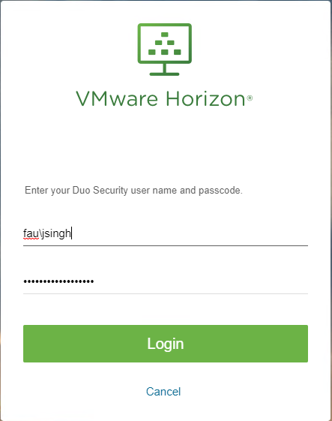

You will receive a DUO push notification on your phone, once you approve the authentication request you will be able to view the VM pool.

1. Once you are able to view the VM pool, click the VM named CON_NONPER to connect to your VM

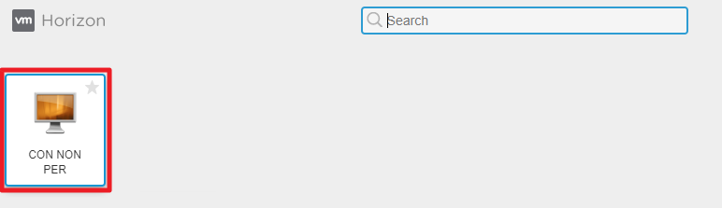

1. Once you have logged into your VM, launch Google Chrome and visit the website [**https://nurdb.fau.edu**](https://nurdb.fau.edu) to access the datacenter